**15.5. Test the Validation Rule for Required Fields**

**White Space Problem**:

Our previous example had a problem with white space. After using white space in the “Last Name” field if we press the submit button our validation cannot detect it and it goes to the “customer-confirmation” page.

Now we have to fix it. We need to trim whitespace from input fields.

**Advanced Spring Solution (@InitBinder)**:

1. @**InitBinder** annotation works as a pre-processor
2. It will pre-process each web request to our controller
3. Method annotated with @**InitBinder** is executed

**Use of @InitBinder**:

1. We will use this to trim Strings
2. Remove leading and trailing white space
3. If String only has white spaces … trim it to null
4. Will resolve our validation problem … whew :-)

**Register Custom Editor in Controller**:

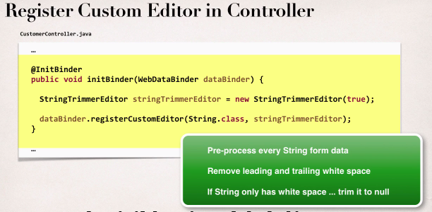

**File: CustomerController.java**:

**package** com.ruhul.odduu.springmvc;

**import** javax.validation.Valid;

**import** org.springframework.beans.propertyeditors.StringTrimmerEditor;

**import** org.springframework.stereotype.Controller;

**import** org.springframework.ui.Model;

**import** org.springframework.validation.BindingResult;

**import** org.springframework.web.bind.WebDataBinder;

**import** org.springframework.web.bind.annotation.InitBinder;

**import** org.springframework.web.bind.annotation.ModelAttribute;

**import** org.springframework.web.bind.annotation.RequestMapping;

@Controller

@RequestMapping("/customer")

**public** **class** CustomerController {

// add an initbinder.. to convert trim input string

// remove leading and trailing whitespace

// resolve issue for our validation

@InitBinder

**public** **void** initBinder(WebDataBinder dataBinder) {

//it is part of Spring API. true means trim to null

StringTrimmerEditor stringTrimmerEditor = **new** StringTrimmerEditor(**true**);

dataBinder.registerCustomEditor(String.**class**, stringTrimmerEditor);

}

@RequestMapping("/showForm")

**public** String showForm(Model theModel) {

theModel.addAttribute("customer", **new** Customer());

**return** "customer-form";

}

@RequestMapping("/processForm")

**public** String processForm(@Valid @ModelAttribute("customer") Customer theCustomer, BindingResult theBindingResult) {

System.***out***.println("Last name: |" + theCustomer.getLastName() + " |");

**if** (theBindingResult.hasErrors()) {

**return** "customer-form";

} **else** {

**return** "customer-confirmation";

}

}

}

15.5. Test the Validation Rule for Required Fields